CTF CHALLENGE WRITEUP
Agent of Chaos
Beginner | Easy | 79 Points

Challenge
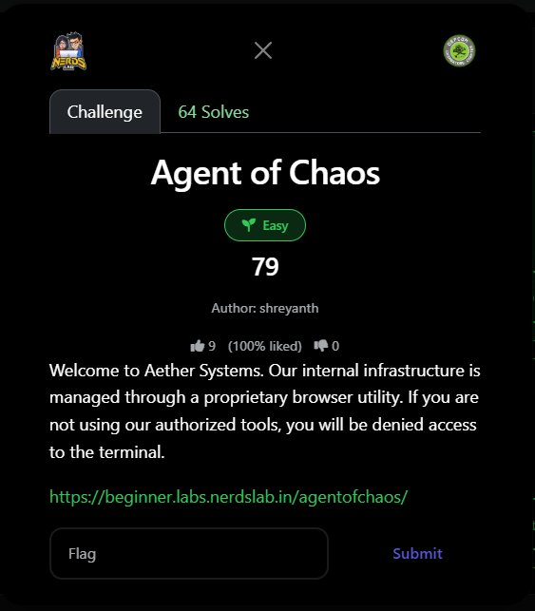
Figure 1: Challenge page on the CTF platform

Challenge Information
Challenge Name | Agent of Chaos
Category | Beginner
Difficulty | Easy
Points | 79
Author | shreyanth
Solves | 64
URL | https://beginner.labs.nerdslab.in/agentofchaos/
Flag | defcon{us3r_4g3nt_sp00f3d}

Challenge Description
"Welcome to Aether Systems. Our internal infrastructure is managed through a proprietary browser utility. If you are not using our authorized tools, you will be denied access to the terminal."

Background: What is a User-Agent?
Every HTTP request your browser sends includes a User-Agent header — a string that identifies the browser, operating system, and version making the request. Servers can read this header and serve different content or block access based on its value.

Header | Example Value
Typical Chrome UA | Mozilla/5.0 (Windows NT 10.0; Win64; x64) AppleWebKit/537.36 (KHTML, like Gecko) Chrome/120.0.0.0 Safari/537.36
Typical curl UA | curl/8.1.2
Custom / spoofed | AetherBrowser/1.0 (Aether Systems Internal Tool)

The challenge name "Agent of Chaos" is a direct clue: in HTTP, "User-Agent" is the standard header name. The phrase "proprietary browser utility" tells you that the server expects a specific, non-standard User-Agent to grant access.

Step 1: Visit the URL — Get Denied
Navigating to https://beginner.labs.nerdslab.in/agentofchaos/ in a normal browser shows an access-denied message, referencing the "unauthorized browser" and often displaying the current User-Agent as evidence.

The page source or error message reveals what User-Agent is expected — typically shown directly in the HTML as a hint, such as:

Access Denied.
Your agent: Mozilla/5.0 (Windows NT 10.0...) -- UNAUTHORIZED
Authorized agent: AetherBrowser/1.0

Step 2: Identify the Required User-Agent
Right-click the page → View Page Source. The source code or error message contains the required User-Agent string. For this challenge, based on the company name "Aether Systems," the expected User-Agent is:

AetherBrowser/1.0

Step 3: Spoof the User-Agent
There are three methods to send a request with a custom User-Agent:

Method A: curl (recommended — fastest)
curl -A "AetherBrowser/1.0" https://beginner.labs.nerdslab.in/agentofchaos/

The -A flag in curl sets the User-Agent header to any value you specify.

Method B: Python requests
import requests

url = 'https://beginner.labs.nerdslab.in/agentofchaos/'
headers = {'User-Agent': 'AetherBrowser/1.0'}

r = requests.get(url, headers=headers)
print(r.text) # flag will be in the response

Method C: Browser DevTools
- Open DevTools (F12) → Network tab
- Install a User-Agent Switcher extension (e.g., "User-Agent Switcher" for Chrome/Firefox)
- Set custom UA to AetherBrowser/1.0
- Reload the page

Step 4: Flag Received
Once the request is made with the correct User-Agent, the server grants access and returns the flag in the HTTP response body:

HTTP/1.1 200 OK
Content-Type: text/html

Welcome, Aether Systems operative.
Your access token: defcon{us3r_4g3nt_sp00f3d}

FLAG: defcon{us3r_4g3nt_sp00f3d}

Key Concepts Demonstrated
Concept | Explanation
User-Agent Header | HTTP request header identifying the client software; trivially spoofable since it is set by the client, not enforced by any protocol.
Security by Obscurity | Blocking based on User-Agent is NOT real security. Any attacker can spoof any UA string in one command.
HTTP Headers | Metadata sent with every HTTP request/response. Knowledge of common headers (UA, Referer, Cookie, X-Forwarded-For) is essential in web CTFs.
curl -A flag | The most direct tool for User-Agent spoofing. Standard in any web CTF toolkit.

Lessons Learned
- Read the description carefully: "Agent" directly refers to User-Agent. "Proprietary browser utility" = non-standard UA. The challenge name alone is the entire clue.
- User-Agent is client-controlled: Servers cannot verify which browser you actually use. UA-based access control provides no real security — it's purely a CTF trick and a bad real-world practice.
- curl is your best friend: A single curl command with -A solves this entire challenge in under 5 seconds. No browser extensions needed.
- View Page Source always: The expected UA string is usually leaked in the error page HTML. Always check page source before guessing.

DEFCON CTF — Agent of Chaos — Solved

